**Solutions:**

**PART 1:**

Qn1.

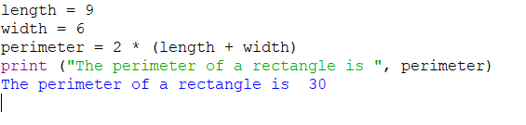

Qn2.

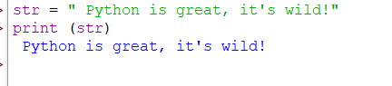

Qn3.

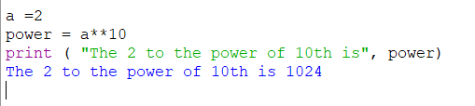

Qn4.

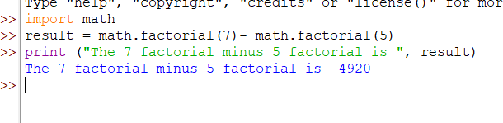

Qn5.

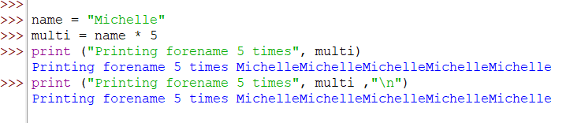

Qn6.

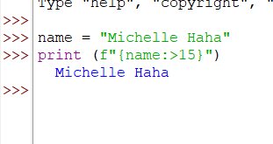

Qn7.

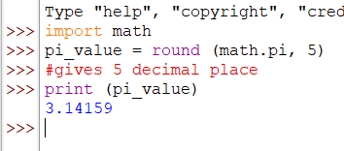

Qn8.

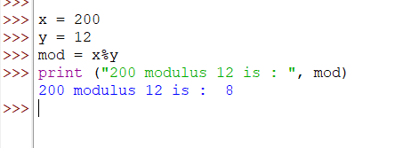

Qn9.

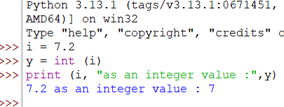

Qn10.

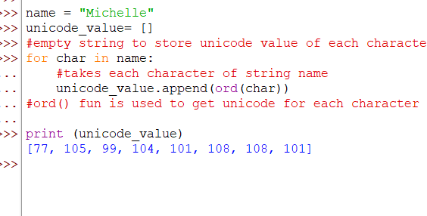

**PART 2:**

Qn1. Program1:

#1. Write a program to take a number input from the user and

# display whether the number is even or odd.

number = int (input("Enter a number: "))

if number%2==0:

    print (number, "is an even number ")

else:

    print (number, "is an odd number ")

Output:

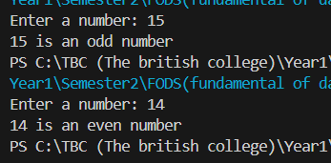

Qn2. Program2:

#2. Write a program that prompts the user for two integer values and

# displays the results of the first number divided by the second,

# with exactly two decimal places displayed.

number1= int (input("Enter the number: "))

number2= int (input("Enter the second number: "))

division = number1/number2

solu=round(division,2)

print ("The quotient after dividing number 1 and number 2 is " , solu)

Output:

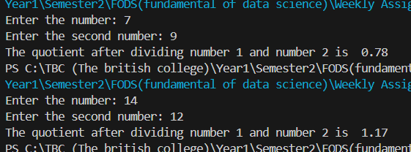

Qn3. Program3:

#3. Write a program that will convert Celsius value to Fahrenheit.

C = int (input ("Enter the Celsius : "))

f = C * (9/5) +32

print ("Converting Celsius degree into Fahrenheit : ", f)

Output:

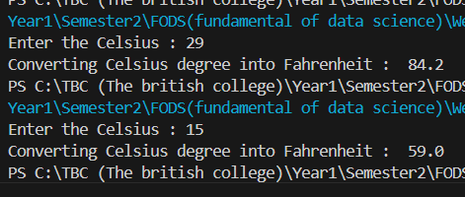

Qn4. Program4:

#Write a program to find the Euclidean distance between two coordinates.

#  Take both the coordinates from the user as input.

import math

x1= int (input("Enter the value of x1 coordinate : " ))

x2= int (input("Enter the value of x2 coordinate : "))

y1= int (input("Enter the value of y1 coordinate : "))

y2= int (input("Enter the value of y2 coordinate : "))

#using euclidean distance formula

ed = math.sqrt(pow((x2-x1),2) + pow((y2-y1),2))

ED= round (ed, 5) #printing only 5 decimal placesS

print ("The Euclidean Distance of the given coordinates is ", ED)

Output:

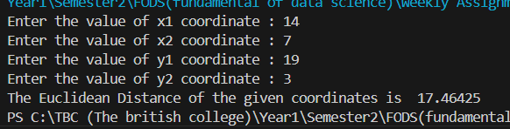

Qn5. Program5:

#5. Write a program to find the simple interest when the value of

# principle, rate of interest and time period is provided by the user.

P= int(input("Please Enter the Principle amount : "))

T= int(input("Please Enter the Time period : "))

R= int(input("Please Enter the Interest rate : "))

si = round((P*T*R)/100,3) #displayed upto 3 decimal place

print ("The Simple Interest is ", si)

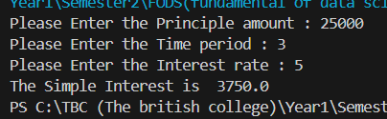Output:

Qn6. Program6:

#6.Write a Python program to find those numbers which are divisible by 7 and multiple of 5,

#between 1500 and 2000 (both included).

num=[] #empty list

num1 = 1500

num2 = 2000

for i in range (num1, num2+1):

    if i%7==0 and i%5==0:

        num.append(i) #used append to store the value in the given empty num list

print (num)

Output:



Qn7. Program7:

#7. Write a Python program that accepts a string and calculates the number of digits and letters.

word= input ("Please Enter a sentence : ")

Num_Letters = 0

Num_Digits = 0

for ch in word: #Iterates over each letter of the sentence

    if ch.isdigit(): #Checks if character is a number or not

        Num_Digits+=1 #if it is it adds by 1

    elif ch.isalpha(): #Checks if character is a string or not

        Num_Letters+=1 #if it is it adds by 1

print (f"Number of letters are : {Num_Letters}")

print (f"Number of digits are : {Num_Digits}")

Output:

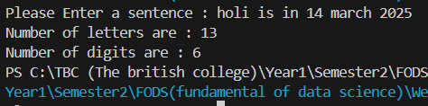

Qn8. Program 8:

#8. Write a program to create a number guessing game for the user.

# The program should ask the user to input a number.

# The program specifications are as mentioned below.

#    I. The program should generate a random number for the answer.

#    II. The program should prompt the user for a number input.

#    III. The program should provide the feedback to the user after each guesses (e.g. “Too high”, “Too low” or “Correct number”).

#    IV. The program should check the user input for 5 times and allow the users to guess for

#    at most 5 times if their input don’t match the answer number.V.

#    If the user is not able to guess the answer within 5 times, the program should display “Game Over” message and exit.

import random

number = random.randint(1,100) # give random from 1 to 100

guess = 0

for i in range (5,0,-1):

    guess= int(input(" Guess The Number: "))

    if guess > number:

        print (" Too High, Guess Lower!!! ")

    elif guess < number:

        print (" Too Low, Guess Higher!!! ")

    elif guess == number:

        print (" Correct number, CONGRATULATIONS!!! ")

        break

    print (f"You have {i-1} guess left")

if guess!=number:

    print (" Game over, Better Luck Next Time!!! ")

Output:

